EE- 5356- DIGITAL IMAGE PROCESSING

PROJECT- 13

BLENDING OF TWO IMAGES

NAME: PAVAI ARCHIMEDES

ST ID: 1001233996

PROCEDURE:

1. Read “Cameraman and Lena” Test Images from course

Webpage: <http://www.uta.edu/faculty/krrao/dip/Courses/EE5356/index.htm>

1. Use the below formula for C:

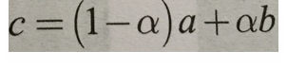

c) **a, b, c** and **α** are used defined variables

**a** = Read Cameraman image

**b =** Read Lena image

**c** = Blend two images and store it on c

**α** = Value of α can be in between 0 to 1 and provided on rum time

PROGRAM:

clc;

clear all;

close all;

b=imread('c:\users\PAVAI ARCHIMEDES\Desktop\lena512.bmp');

a=imread('c:\users\PAVAI ARCHIMEDES\Desktop\cameraman.bmp');

b=imresize(b,[256,256]);

[m,n]=size(a);

alpha1=input(' enter the value of alpha:');

alpha2=input('enter the value of alpha:');

alpha3= input('enter the value of alpha:');

alpha4= input('enter the value of alpha:');

for i=1:m

for j=1:n

c1(i,j)=(1-alpha1)*a(i,j)+alpha1*b(i,j);

c2(i,j)=(1-alpha2)*a(i,j)+alpha2*b(i,j);

c3(i,j)=(1-alpha3)*a(i,j)+alpha3*b(i,j);

c4(i,j)=(1-alpha4)*a(i,j)+alpha4*b(i,j);

end

end

figure(1);

imshow(c1);

title('blended img for alpha=0.2');

figure(2);

imshow(c2);

title('blended img for alpha=0.4');

figure(3);

imshow(c3);

title('blended img for alpha=0.6');

figure(4);

imshow(c4);

title('blended img for alpha=0.9');

RESULTS:

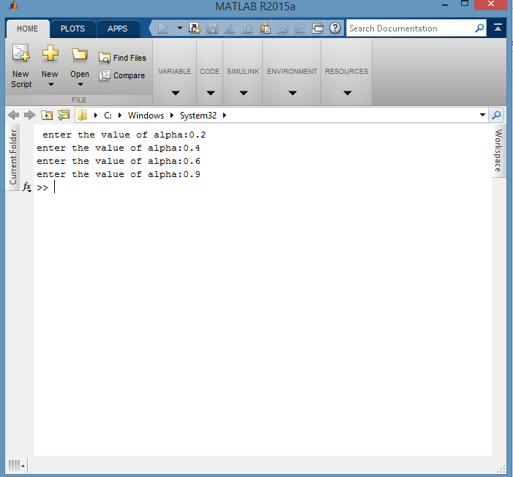

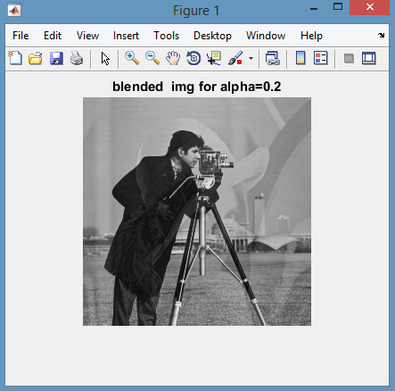

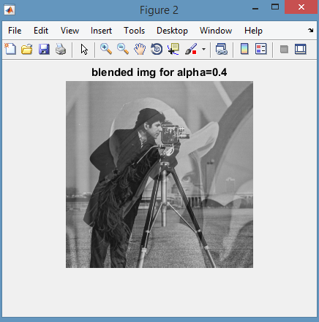

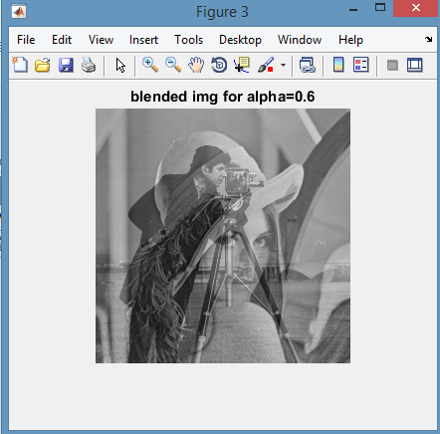

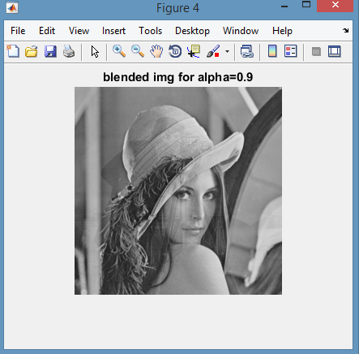

CONCLUSION:

The above mentioned procedure is followed and for various value of alpha the blending of two images is done.